Slide 1

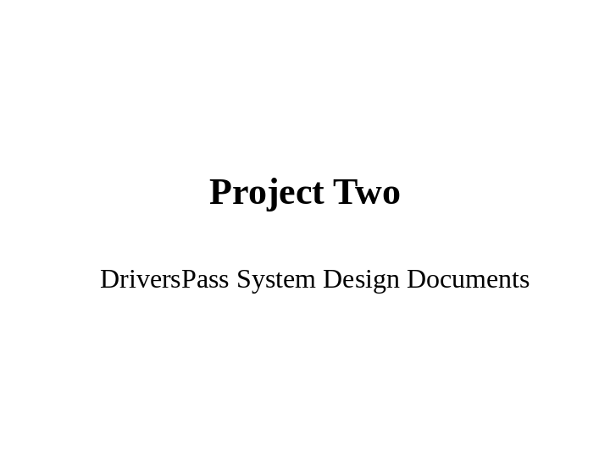

Slide 2

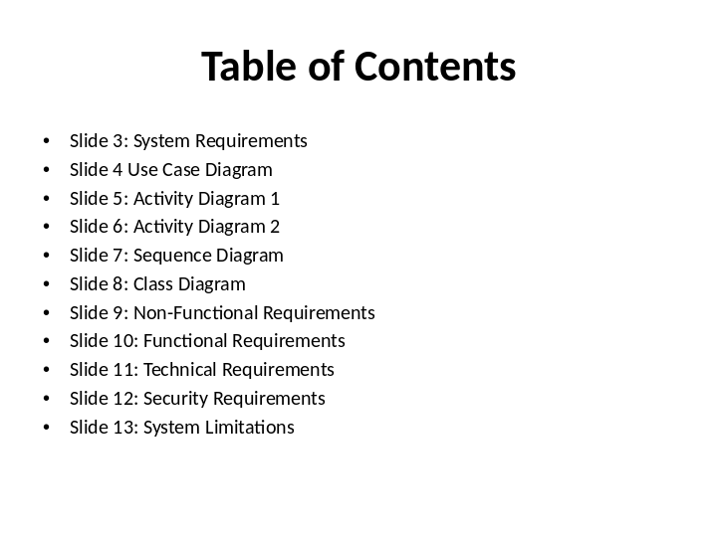

Slide 3

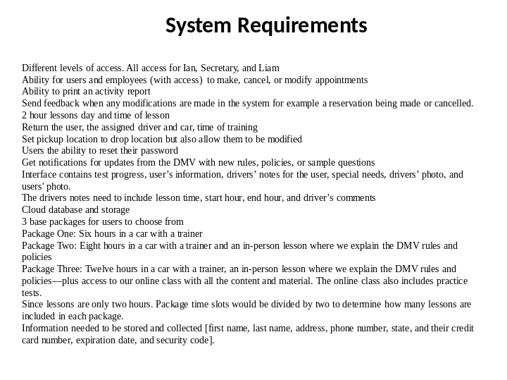

Slide 4

The use case diagram displayed shows the different object necessary to access and navigate the DriverPass website. Several objects have several objects attached to them. For example, the register object is related to the create username/password, verify email, and update database. They have an include relationship because once you perform the account registration the other 3 will process. The login object has another form of relationship where it is extended to a log in error message display. This message will not always be displayed because if a successful log in occurs the message is not necessary. The different actors in the scenario include the customer both new and existing as well as the DMV, Ian(IT specialist) and Ian the boss.

Slide 5

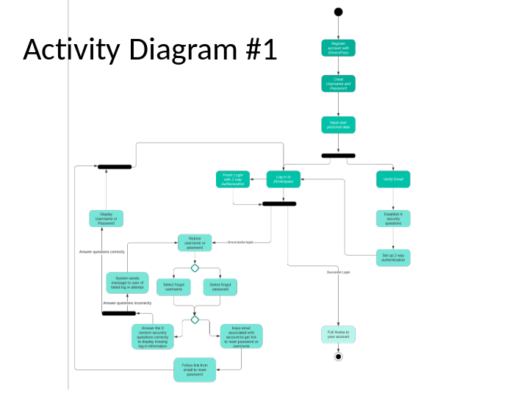

The activity diagram above goes over the use case of registering and logging in to DriversPass. The register process begins with creating a username and password as well as inputting your personal data (such as email, address, driving history, and credit card information just to name a few examples). Next we reach our first fork in the diagram. You can go straight to log in process without a 2 way authentication or you can go to your registered email and verify it. While verifying your email you will select 6 questions/answers and 2 way authentication process which will lead to the log in process. The log in process leads to the 2 way authentication or to the next fork in the activity diagram. This fork involves whether the log in process is successful or not. If it is successful you will have access to your user account for DriverPass. If the log in process is unsuccessful the option to retrieve username and password appears. You have to make a decision here to either select the link to retrieve your username or password. Once you make that decision you reach another decision point. You can decide to either answer 3 of your 6 security questions at random or input the email associated with your account to get your username and a link to reset password sent to you. Once you click the link to reset your password you will go through the log in process again. If you instead choose to answer 3 random security questions your answers determine where the activity goes from there. If you answer the questions incorrectly the system will send an email to the associated email of the unsuccessful login attempt and you will be sent back to the username/password retrieval page. If you answer the questions correctly the username or password depending on what you chose earlier will be displayed on screen and then you will be sent to the log in page.

Slide 6

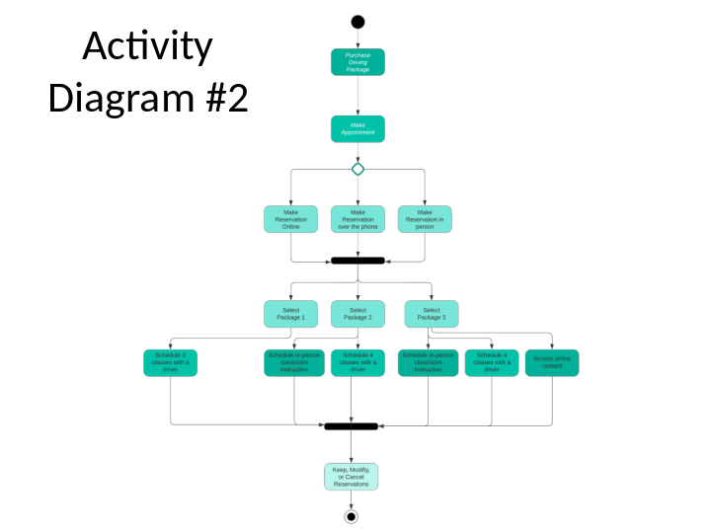

The use case being described in the activity diagram displayed is purchasing a driving package. The process begins with making an appointment to make a reservation either online, on the phone, or in person. The reservation leads to the decision of package the user would like to purchase. The different functions with each package will then need to be scheduled. Lastly, you can either keep, modify, or cancel your reservation.

Slide 7

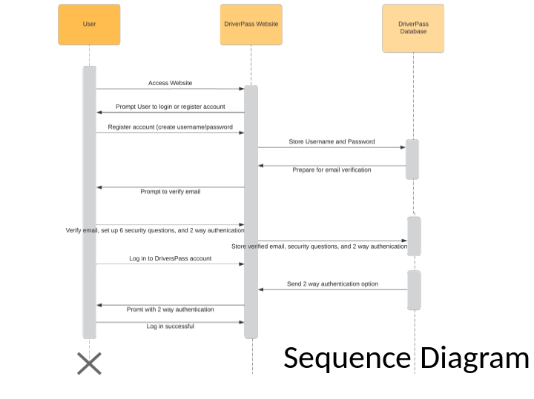

I chose to use the first activity diagram which described the use case of registering with the DriverPass website. The three characters in this diagram are the user, the website, and the database. The sequence begins with a user accessing the DriverPass website. The website will then prompt the user to login or register if they don’t have an account. The User will then register an account where the website will pass the admin data to the database. The database will use the stored email address to send the website the option to verify the email. The user will follow the link to verify, make security questions and set up 2 way authentication. These login methods will be passed to the website and then stored into the database. Once this registration process is complete the user can login and access the website.

Slide 8

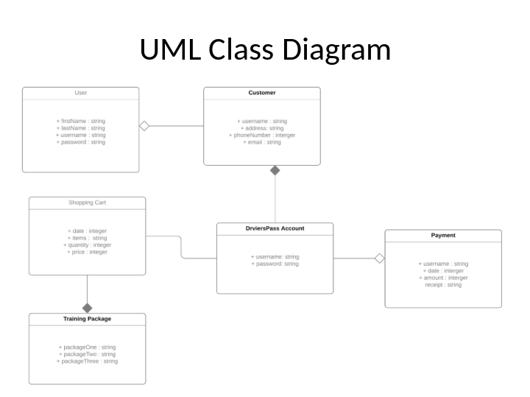

The above UML Class diagram provides the classes necessary to begin developing the code for DriverPass website. The class users is the start since everyone on the website will need to input admin data and create a username/password. The user class has an aggregation relationship with customer because a user is not always a customer. A user could also be the employees of DriverPass. The customer has a composite relationship with the DriverPass account because if the account goes away so does the customer. The DriverPass account is also linked to the payment and shopping cart class. The shopping cart class extends the training package.

Slide 9

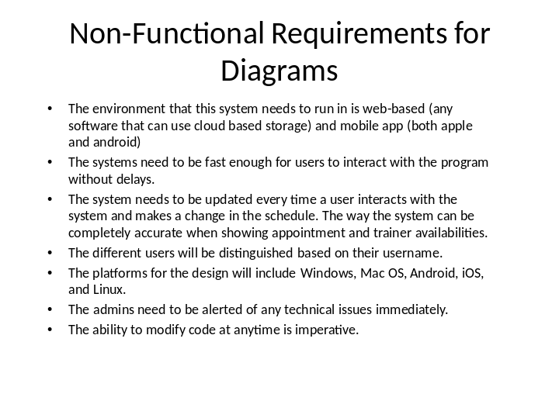

Slide 10

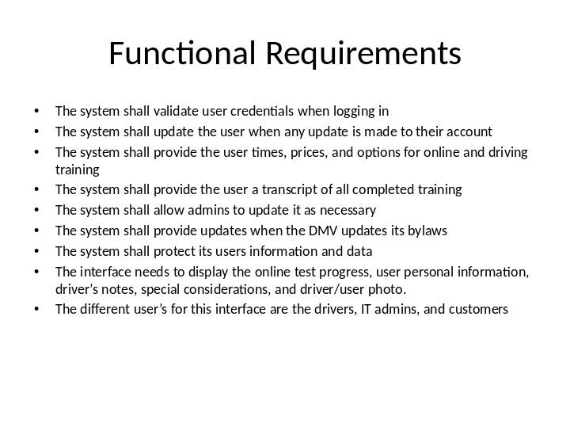

Slide 11

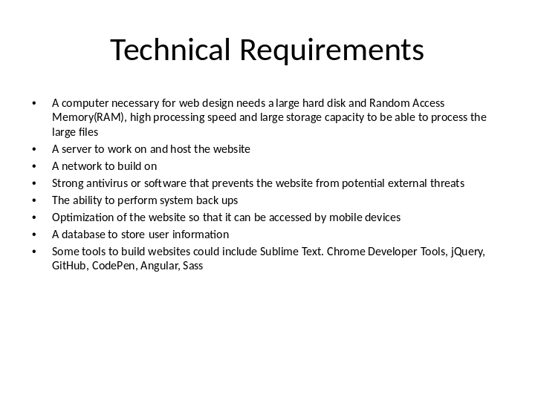

Slide 12

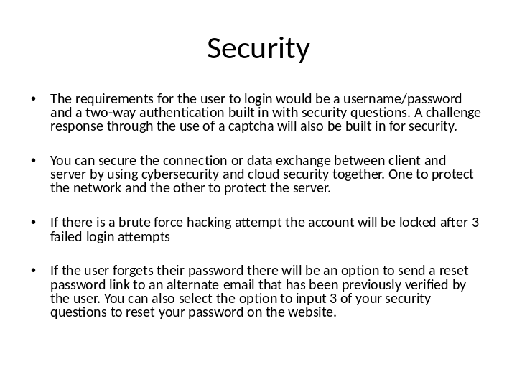

Slide 13

